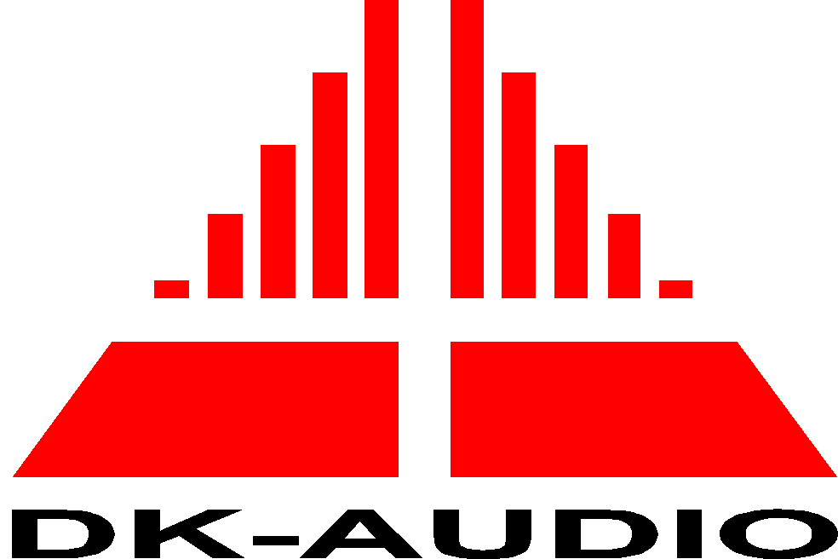


EC Declaration of Conformity
In accordance with EN 45014

We: DK-Audio

of Marielundvej 37D – 2730 Herlev - Denmark

declare under our sole responsibility that the product

Equipment type Digital and analog component/composite WFM.
Model name PT 5664/50

Serial number

to which this declaration relates is in conformity with the following product family standard(s) and used basic standards in accordance to the following Directives:

73/23/EEC Low Voltage Directive (and its amending directives)

89/336/EEC Electromagnetic Compatibility Directive (and its amending directives)

(Emission)

EN 55022/1987 - Class A Radiated electromagnetic field emission

(Immunity)

EN 50082-1/ 1992 - Performance criteria B

(Safety Requirements)

IEC348, 1978, safety class I:
Safety Requirements for electronic measuring apparatus.

Signed by:

Name: Karsten Hansen

Position: CEO

Place of Issue: Marielundvej 37

Date:

